NAME: Gundupalli Srujan Deep

Reg: 192125009

Course-CSA0978

1.

import java.util.\*;

public class lexicograph {

public static void main(String[] args)

{

Scanner c= new Scanner(System.*in*);

System.*out*.print("enter string 1=");

String a=c.nextLine();

Scanner d= new Scanner(System.*in*);

System.*out*.print("enter string 2=");

String b=d.nextLine();

String str1 = a;

String str2 = b;

System.*out*.println("String 1: " + str1);

System.*out*.println("String 2: " + str2);

int result = str1.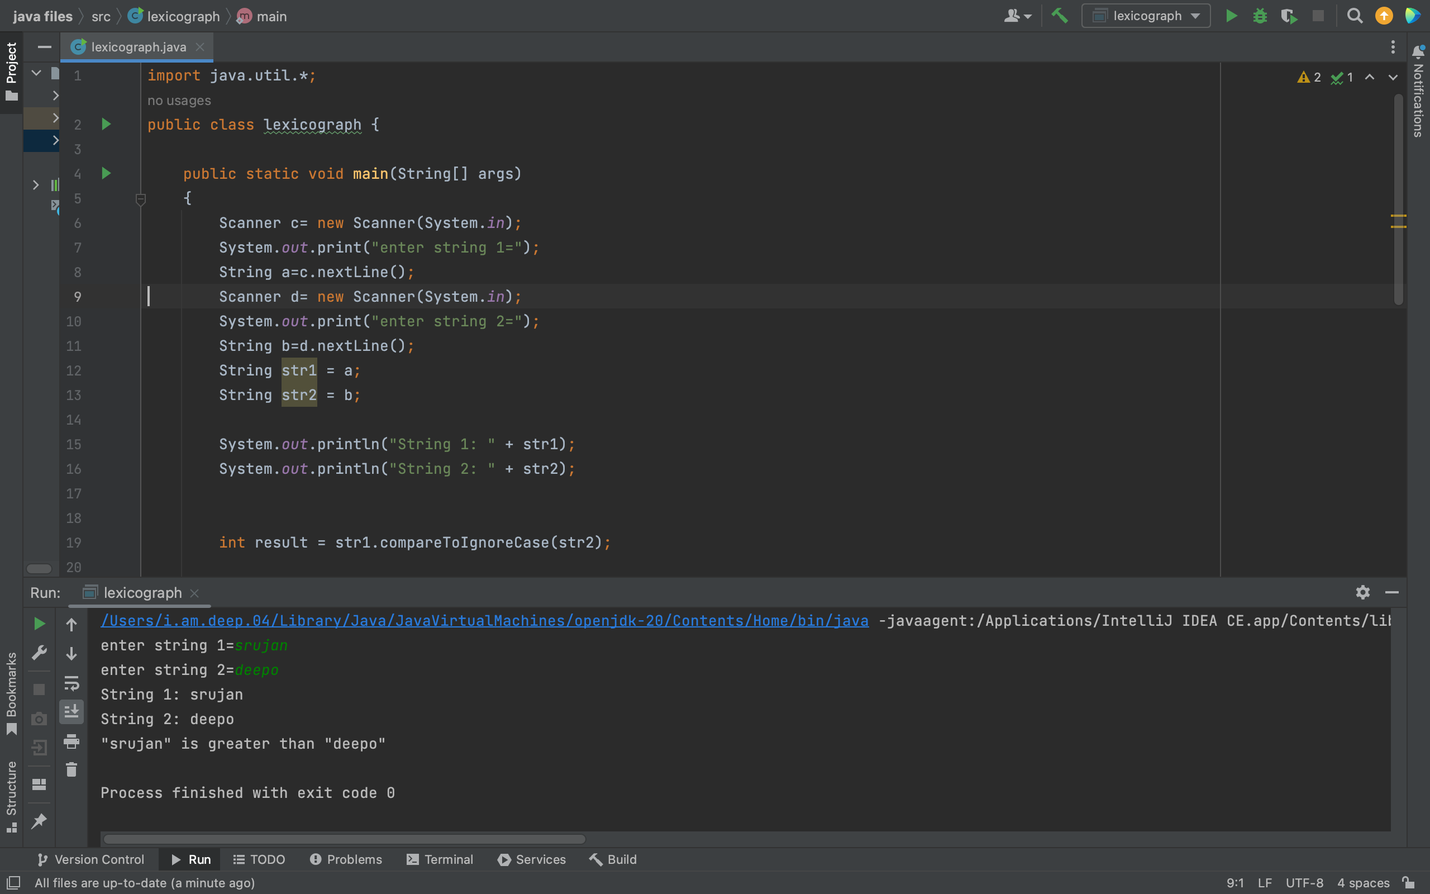compareToIgnoreCase(str2);

if (result < 0)

{

System.*out*.println("\"" + str1 + "\"" +

" is less than " +

"\"" + str2 + "\"");

}

else if (result == 0)

{

System.*out*.println("\"" + str1 + "\"" +

" is equal to " +

"\"" + str2 + "\"");

}

else

{

System.*out*.println("\"" + str1 + "\"" +

" is greater than " +

"\"" + str2 + "\"");

}

}

}

2.

import java.util.\*;

class stringendwith {

public static void main(String[] args) {

Scanner c= new Scanner(System.*in*);

System.*out*.print("enter string 1=");

String a=c.nextLine();

Scanner d= new Scanner(System.*in*);

System.*out*.print("enter string 2=");

String b=d.nextLine();

String str1 = a;

String str2 = b;

if (str1.endsWith(str2)) {

System.*out*.println("String ends with " + str2);

} else {

System.*out*.println("String does not end with " + str2);

}

}

}

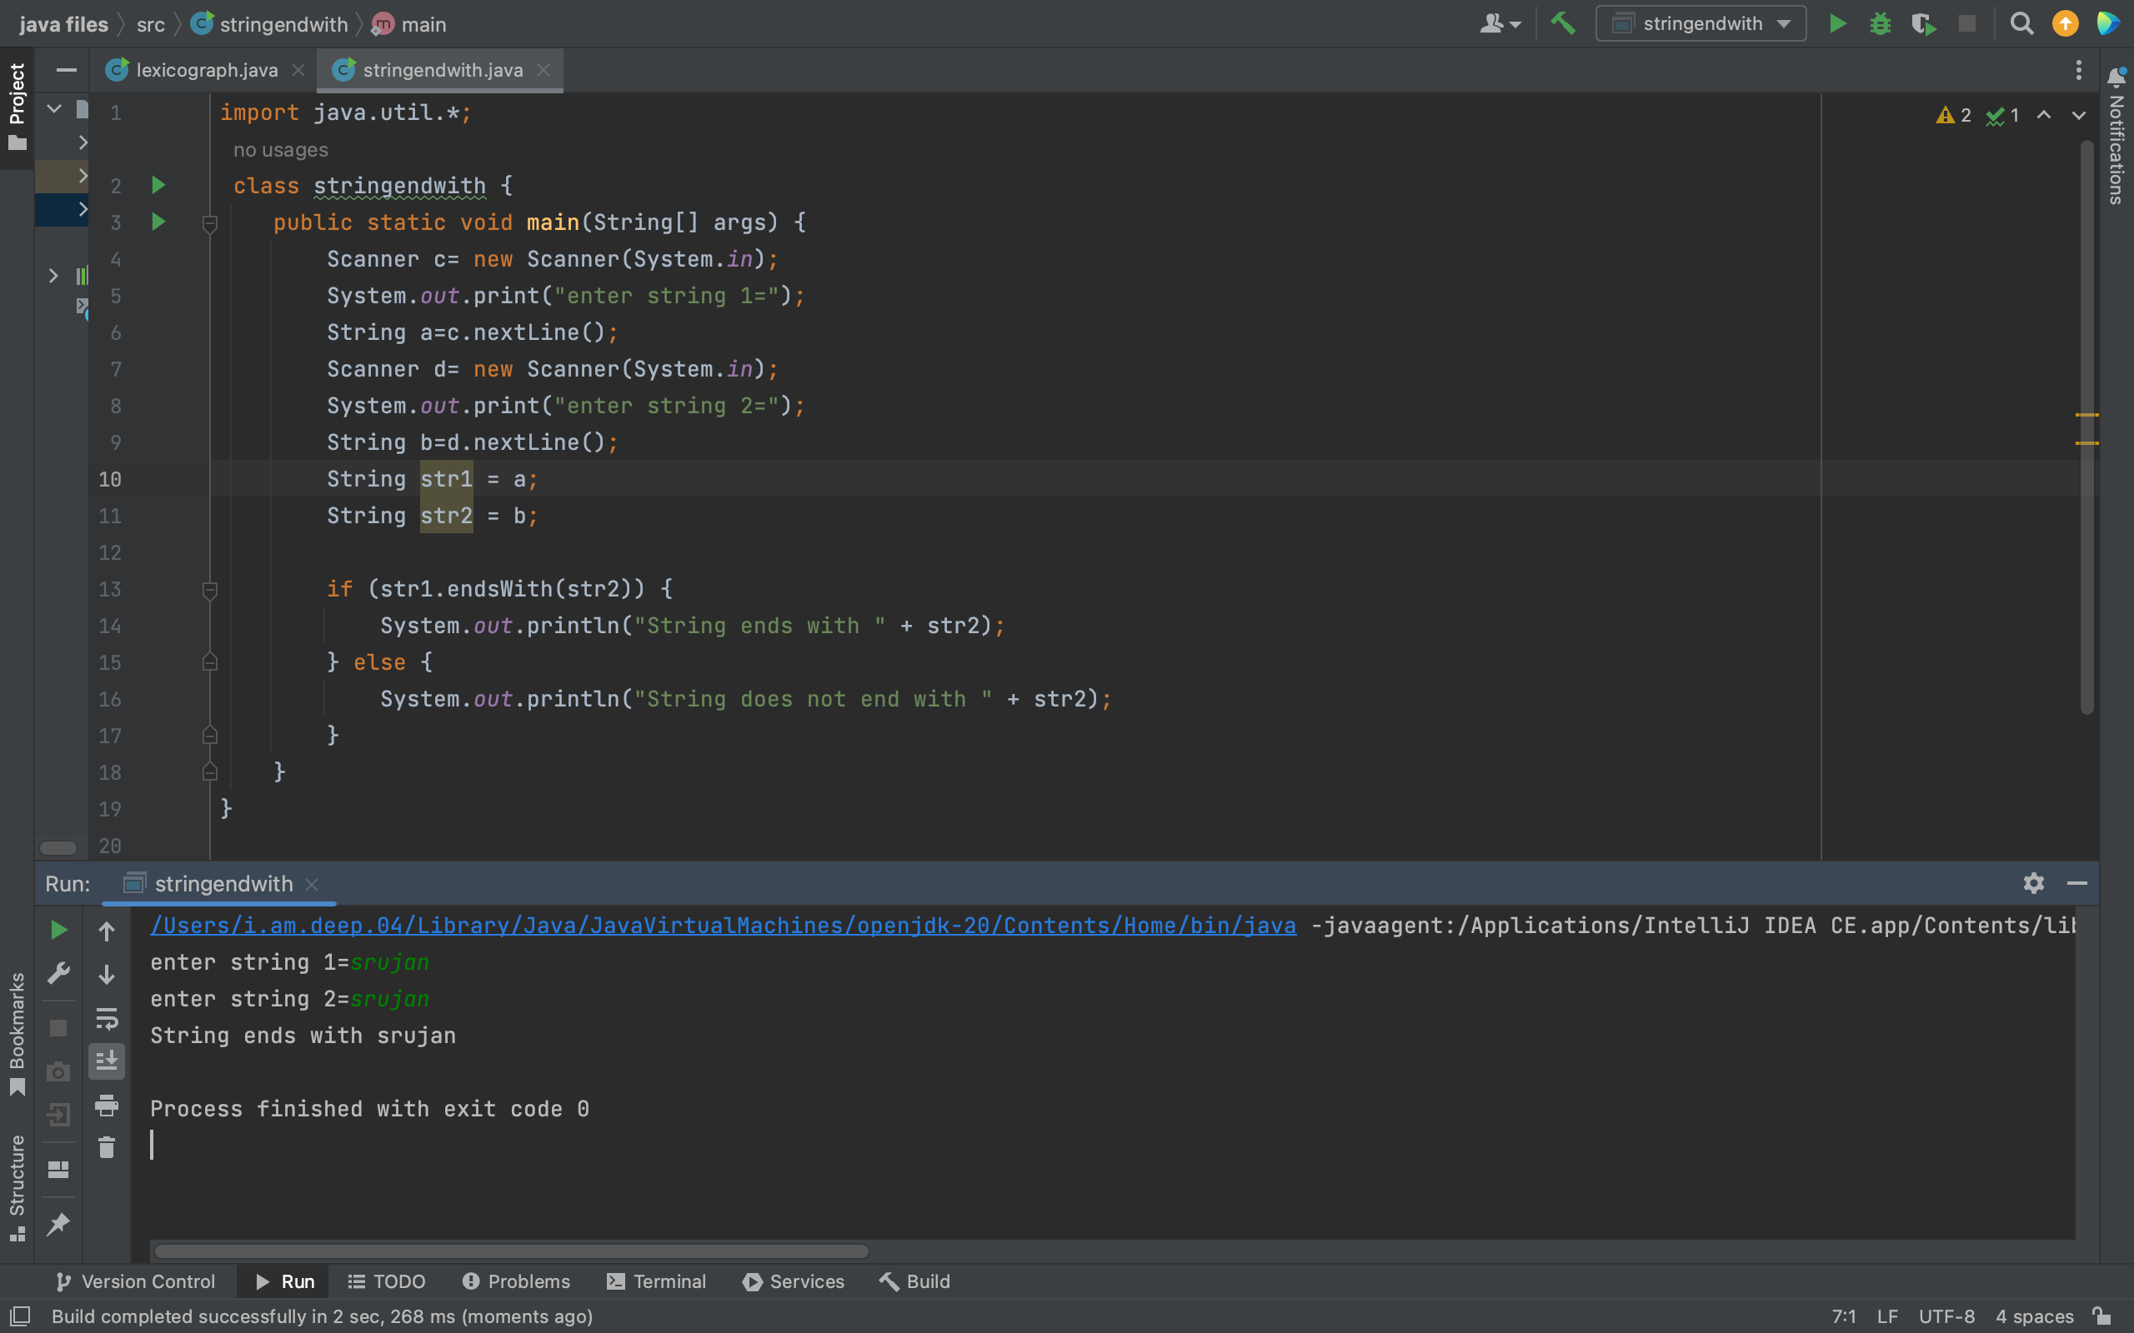

3.

import java.time.LocalDateTime;

import java.time.format.DateTimeFormatter;

public class date {

public static void main(String[] args) {

LocalDateTime dateTime = LocalDateTime.*now*();

DateTimeFormatter formatter = DateTimeFormatter.*ofPattern*("dd/MM/yyyy HH:mm:ss");

String formattedDateTime = dateTime.format(formatter);

System.*out*.println("Current Date and Time: " + formattedDateTime);

}

}

4.

import java.util.Scanner;

public class index{

public static void main(String[] args) {

Scanner d= new Scanner(System.*in*);

System.*out*.print("enter string =");

String a=d.nextLine();

String 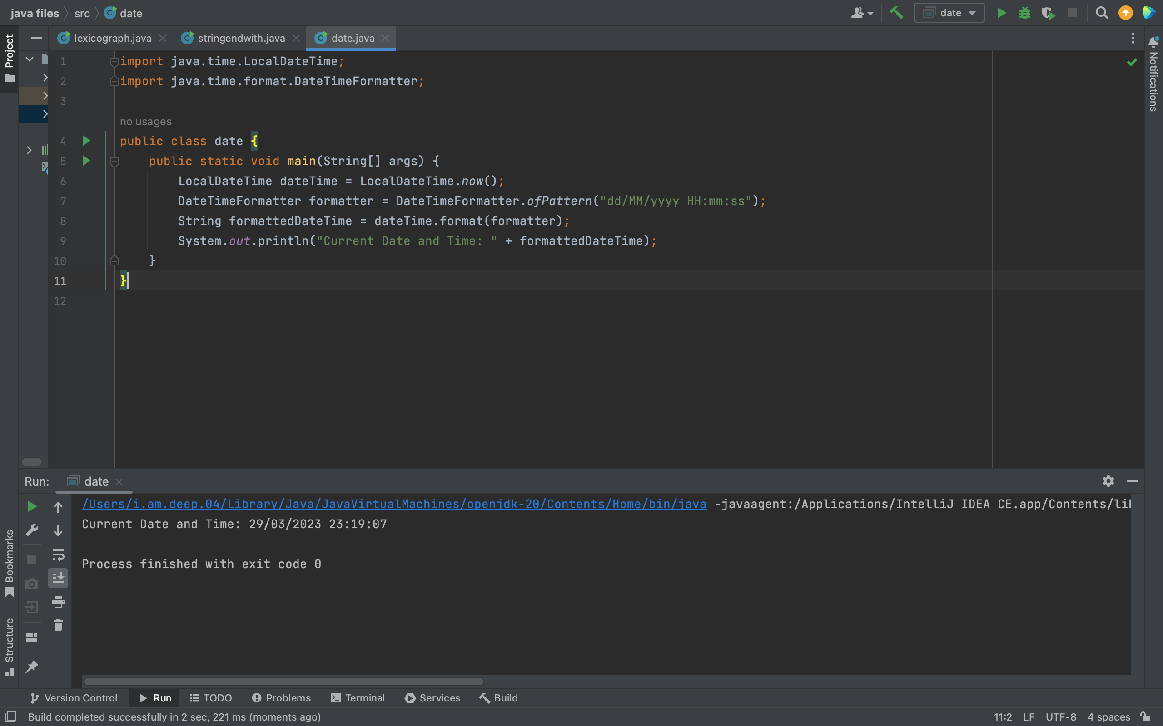str = a;

for (char c = 'a'; c <= 'z'; c++) {

int index = str.indexOf(c);

if (index != -1) {

System.*out*.println(c + " found at index " + index);

}

}

}

}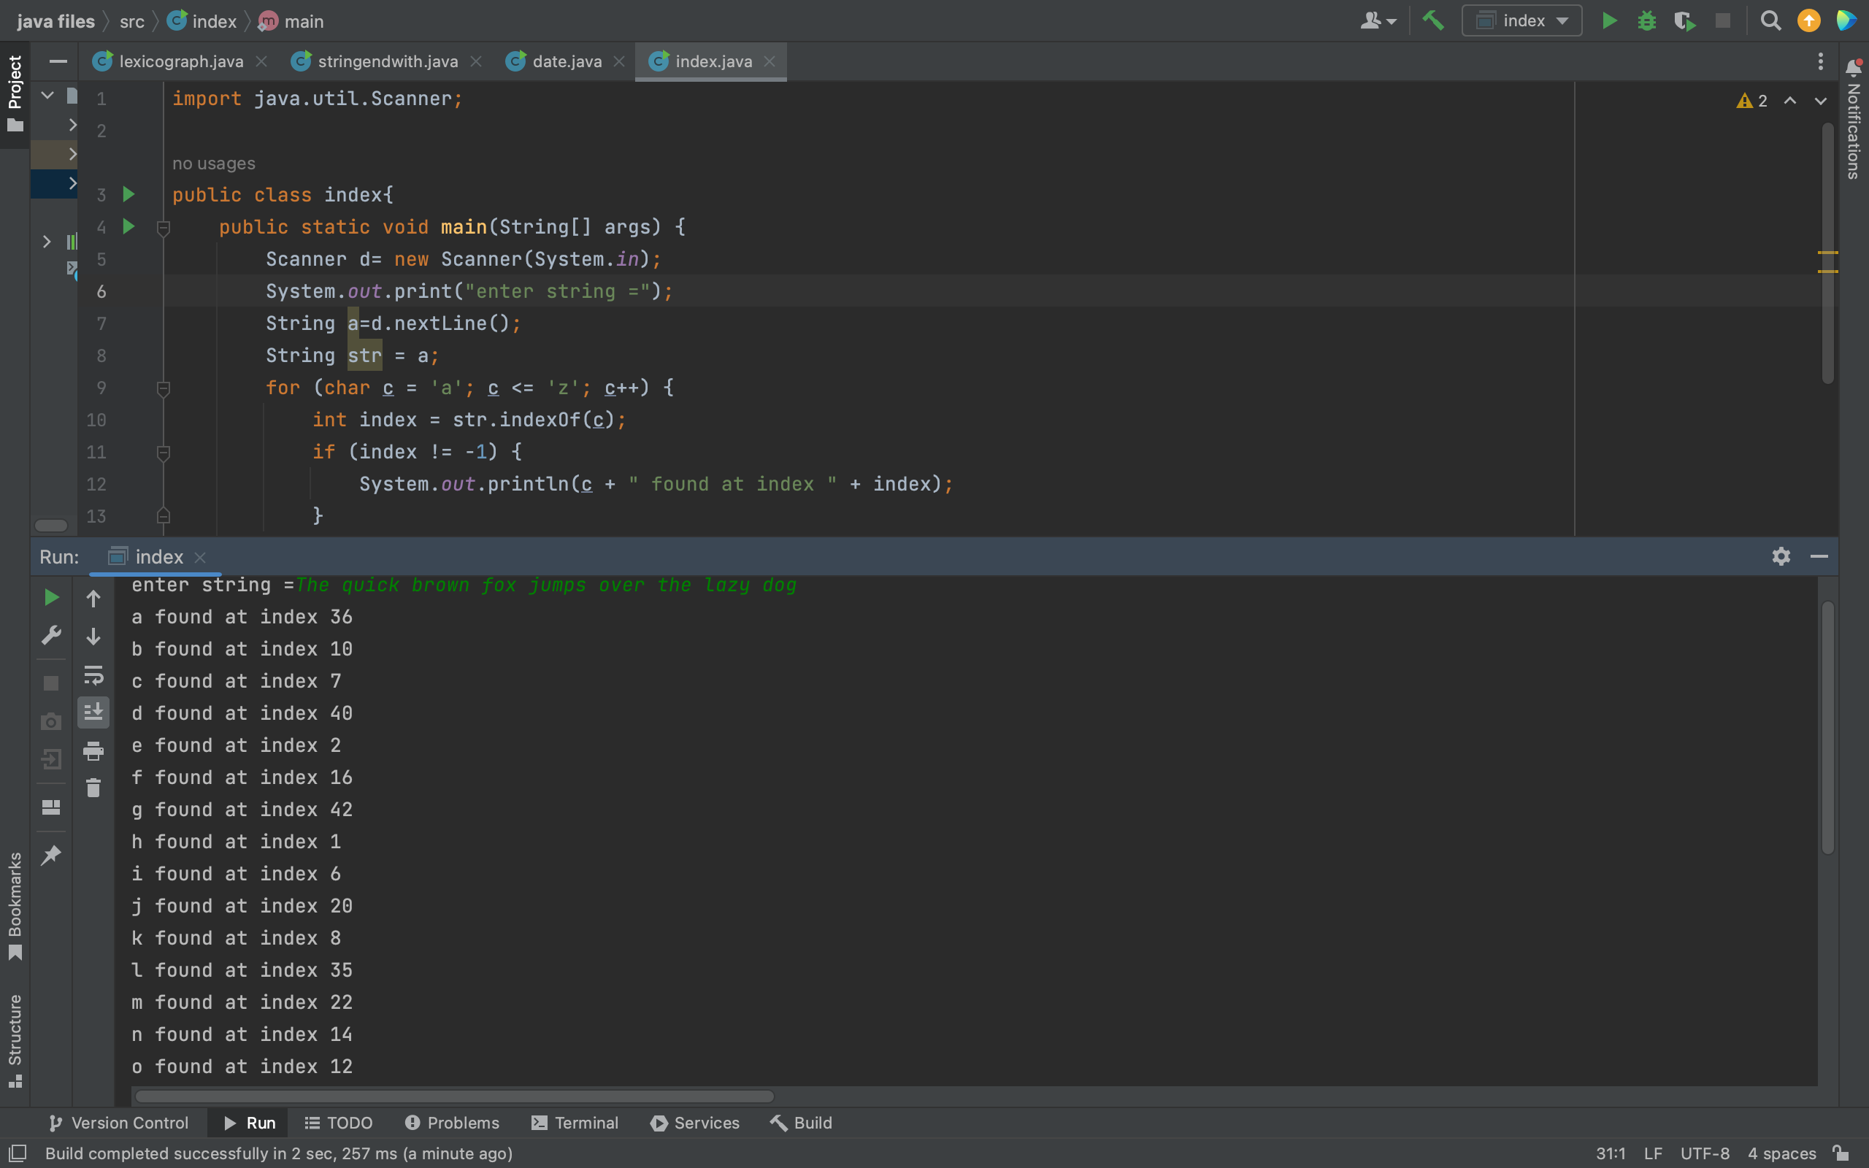

5.

import java.util.\*;

public class replacesubstring {

public static void main(String[] args) {

Scanner c= new Scanner(System.*in*);

System.*out*.print("enter string =");

String a=c.nextLine();

String str = a;

String replacedStr = str.replaceAll("fox", "cat");

System.*out*.println(replacedStr);

}

}

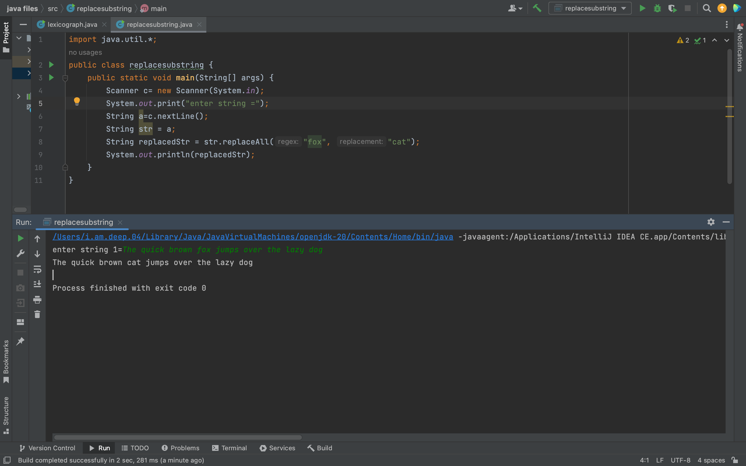

6.

import java.util.Scanner;

public class substringbetweenposition {

public static void main(String[] args) {

Scanner c= new Scanner(System.*in*);

System.*out*.print("enter string =");

String a=c.nextLine();

String str = a;

int startIndex = 10;

int endIndex = 25;

String subStr = str.substring(startIndex, endIndex);

System.*out*.println(subStr);

}

}

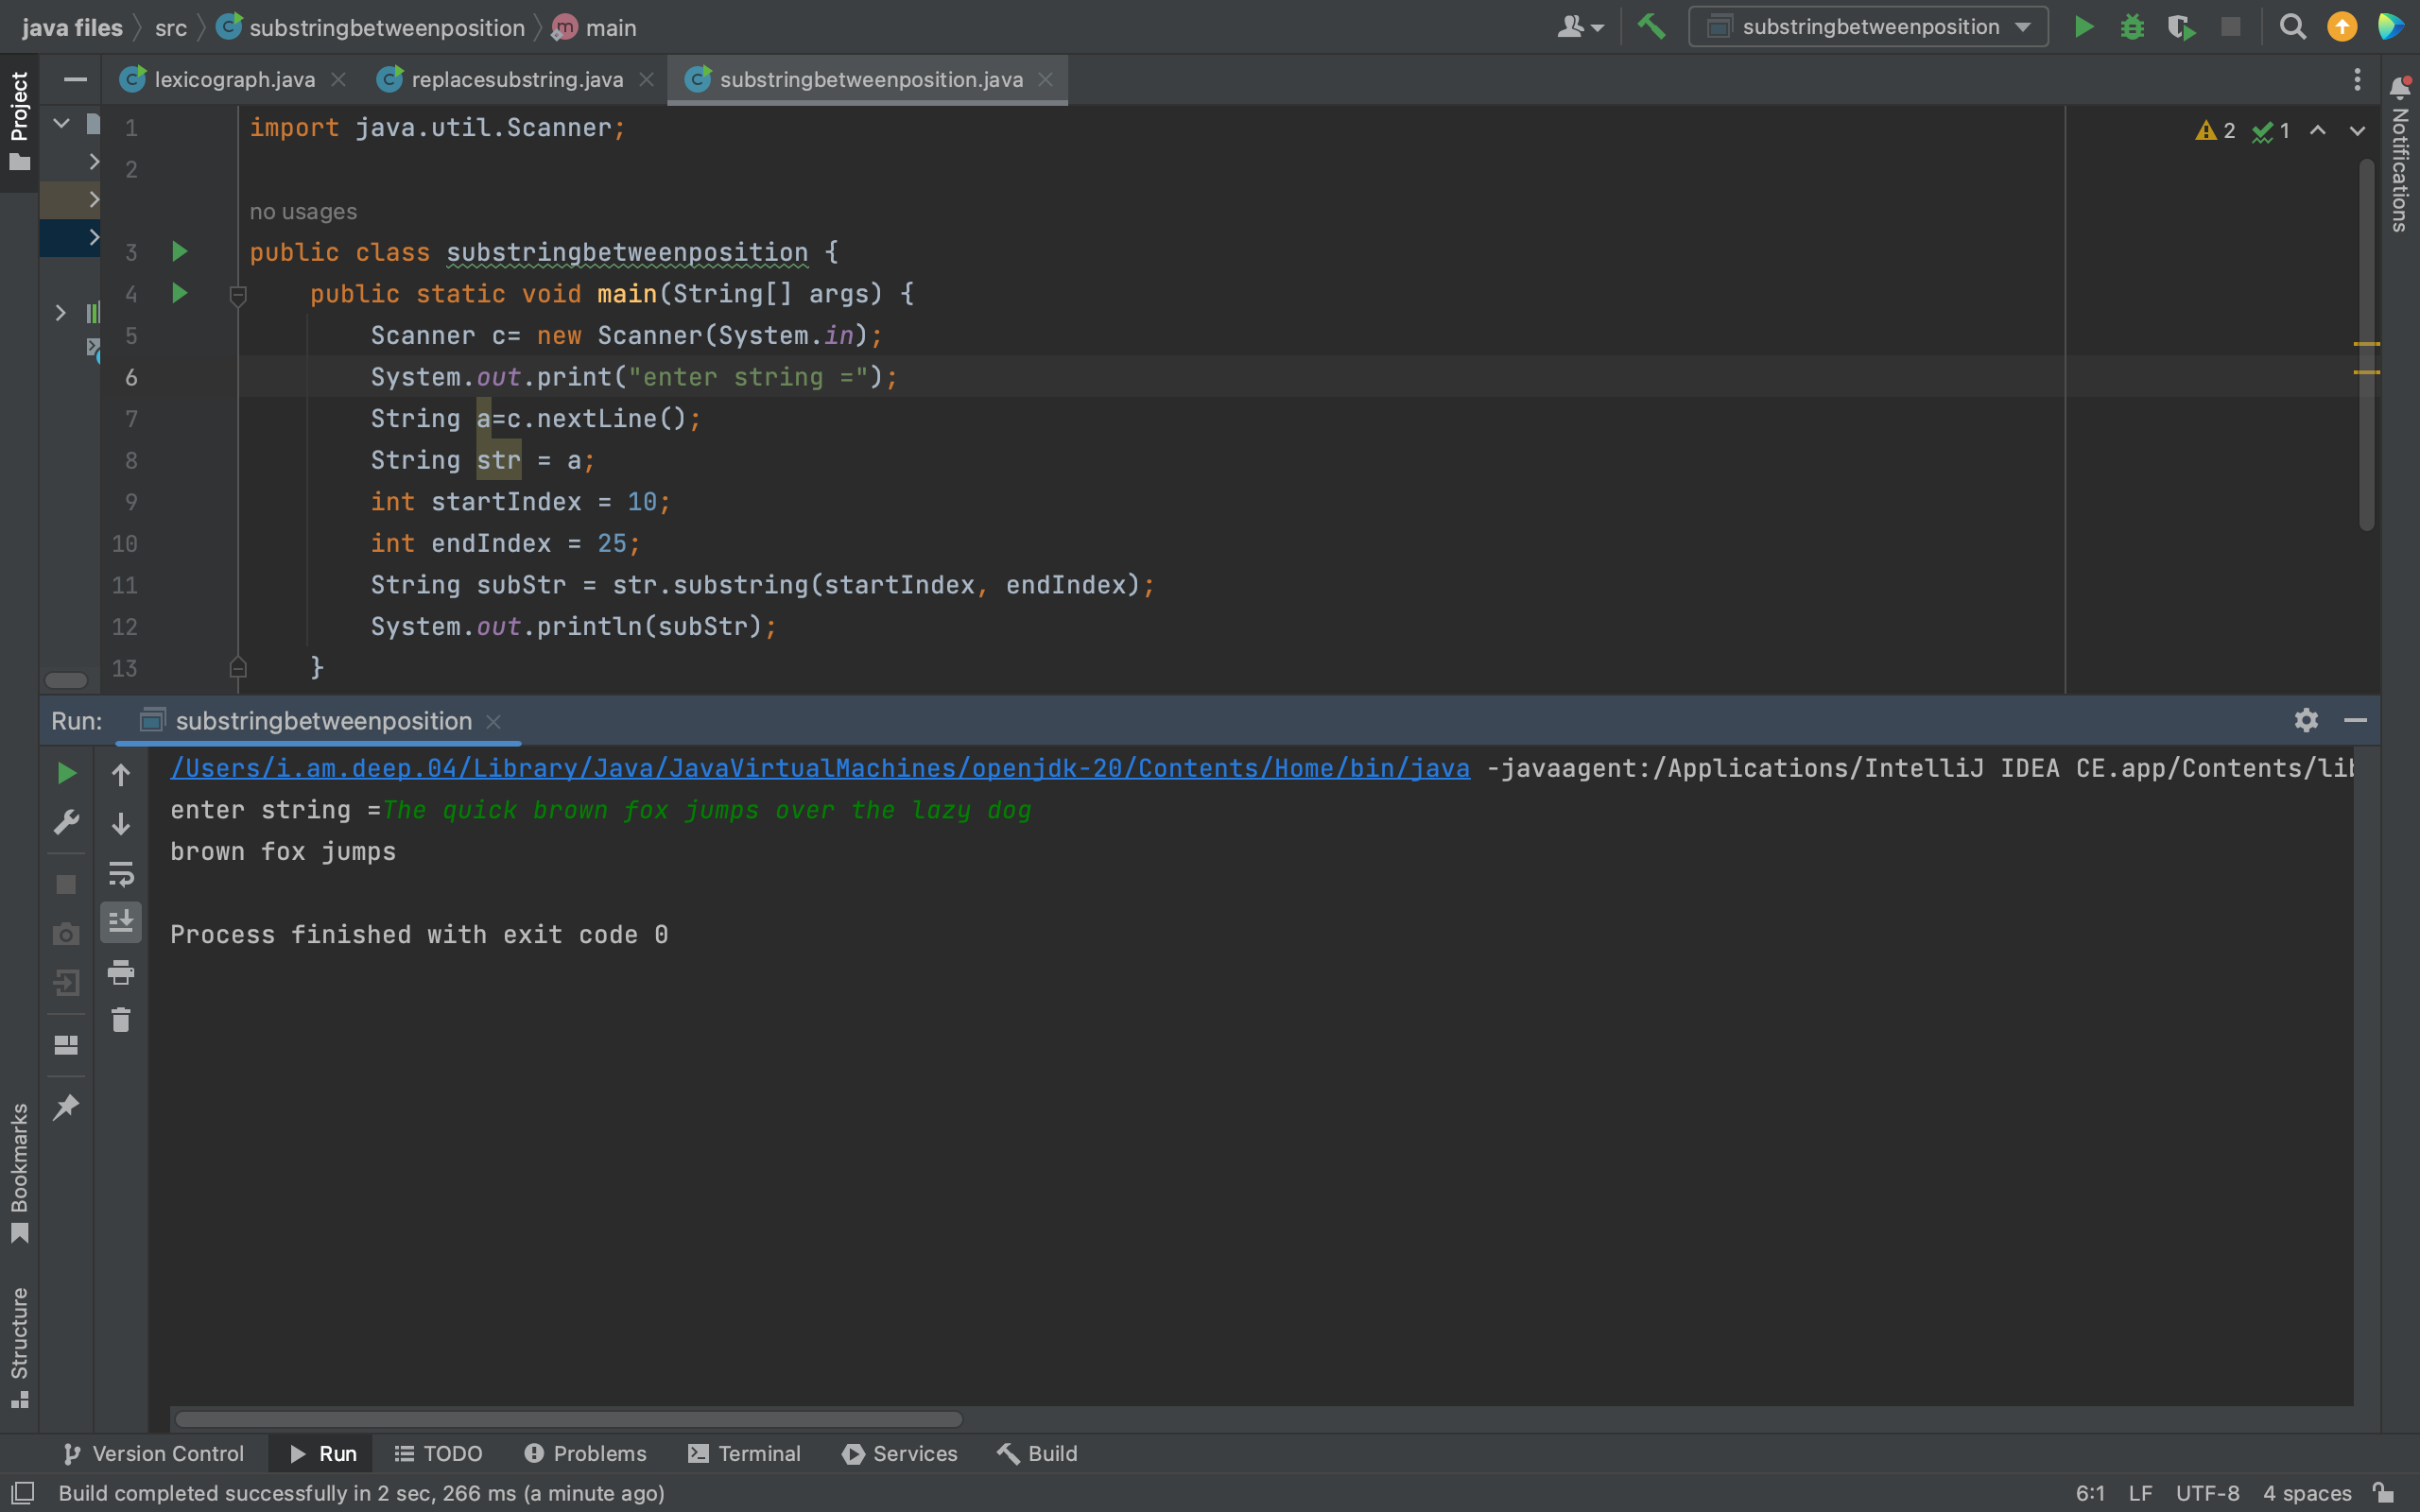

7.

import java.util.\*;

public class whitespace {

public static void main(String[] args) {

Scanner c= new Scanner(System.*in*);

System.*out*.print("enter string =");

String a=c.nextLine();

String str = a;

String trimmedStr = str.trim();

System.*out*.println(trimmedStr);

}

}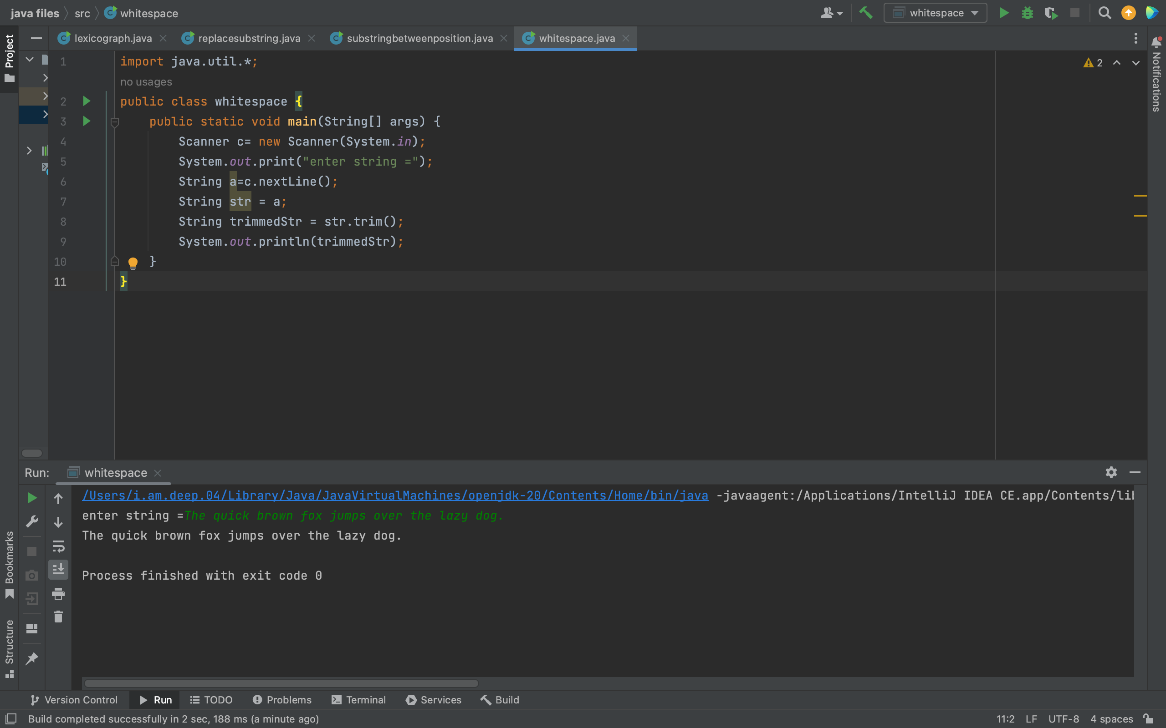

8.

import java.util.\*;

public class stringtolowercase {

public static void main(String[] args) {

Scanner c= new Scanner(System.*in*);

System.*out*.print("enter string =");

String a=c.nextLine();

String str = a;

String lowerCaseStr = str.toLowerCase();

System.*out*.println(lowerCaseStr);

}

}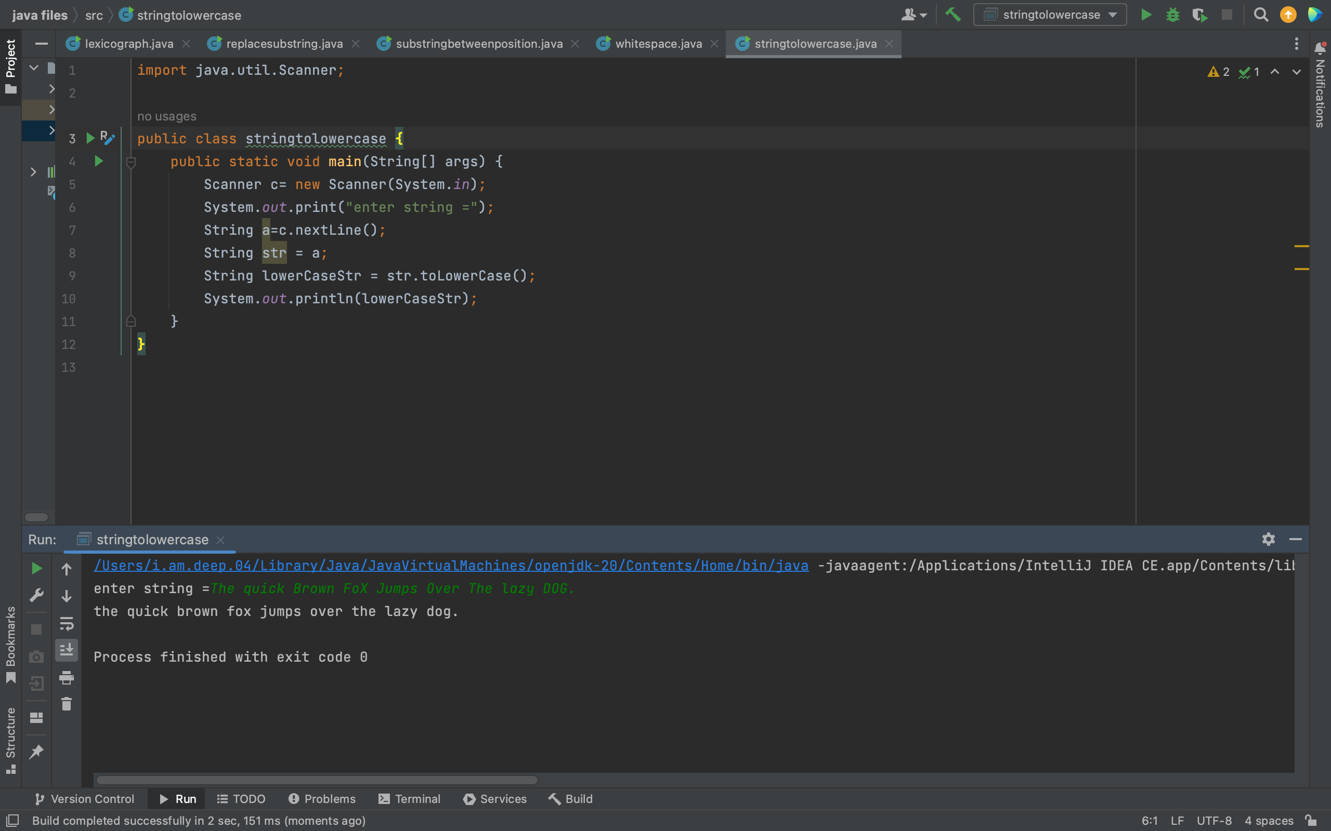

9.

import java.util.\*;

public class stringlength{

public static void main(String[] args) {

Scanner scanner = new Scanner(System.*in*);

System.*out*.print("Enter a string: ");

String inputString = scanner.nextLine();

int stringLength = 0;

for (int i = 0; i < inputString.length(); i++) {

stringLength++;

}

System.*out*.println("The length of the string is: " + stringLength);

}

}

2.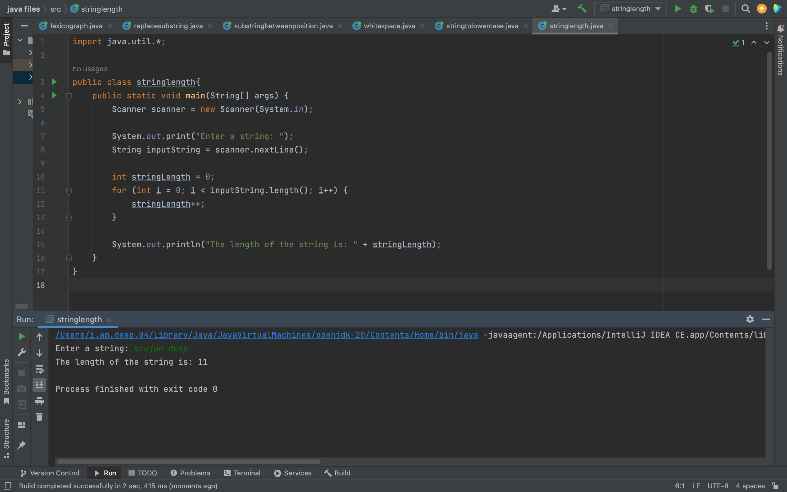

public class Account {

private double balance;

public Account() {

balance = 0;

}

public Account(double initialBalance) {

balance = initialBalance;

}

public double getBalance() {

return balance;

}

public void deposit(double amount) {

balance += amount;

}

public void withdraw(double amount) {

if (amount > balance) {

System.out.println("Insufficient funds. A $5 penalty will be charged.");

balance -= 5; } else {

balance -= amount;

}

}

public void addInterest(double rate) {

double interest = balance \* rate / 100;

balance += interest;

}

}

4.

import java.io.\*;

import java.util.\*;

class Factor {

public static void main(String args[]) {

try {

Scanner sc=new Scanner(System.in);

int count=0, n=100, i, j=n-1, m=4;

int[] a=new int[n];

System.out.println("Enter the number:");

n=sc.nextInt();

if (n <= 0) {

System.out.println("Enter valid number");

} else {

for (i = 1; i <= n; i++) {

if (n % i == 0) {

a[j] = n/i;

System.out.println("..." + a[j]);

count++;

j--;

}

}

System.out.println("The number of factors:" + count);

}

System.out.println((m+1) + "th item " + a[m]);

} catch(Exception e) {

System.out.println("Enter only numbers");

}

}

}

3.

1.

public class Solution {

public int strStr(String haystack, String needle) {

if (needle.isEmpty()) return 0;

int h = haystack.length();

int n = needle.length();

if (h < n) return -1;

for (int i = 0; i <= h - n; i++) {

if (haystack.substring(i, i + n).equals(needle)) {

return i;

}

}

return -1;

}

}

2.

public class Solution {

public int lengthOfLastWord(String s) {

int len = 0;

for (int i = s.length() - 1; i >= 0; i--) {

if (s.charAt(i) == ' ') {

if (len > 0) {

return len;

}

} else {

len++;

}

}

return len;

}

}